Improving Revenue at SweetAroma: A Business Analytics and Predictive Modelling Approach

1. Executive Summary:
SweetAroma aims to increase revenue by understanding the factors that influence customer spending and by identifying high-value customers in advance. Using July 2025 order data, this report analyses customer background and behaviour to determine spending drivers and develops a predictive model to estimate future customer revenue.
The analysis shows that historical customer value, website engagement, and acquisition channel strongly influence revenue. Customers acquired through paid advertising channels and customers with higher historical spending generate significantly higher order values. A Gradient Boosting regression model was selected as the most accurate predictive approach after visual and quantitative comparison across multiple models.

2. Business Requirement and Analytical Approach:
The management requested answers to two business questions:
- Which customer background and behavioural factors cause customers to spend more or less per order?
- Can future order revenue be predicted accurately for marketing purposes?
To address these questions, the following steps were undertaken:
- Data quality assessment and cleaning
- Exploratory data analysis using tables and figures
- Comparative modelling using multiple prediction techniques
- Model validation and visual diagnostics
- Business interpretation of results
Python was used as the analytical tool due to its ease in supporting statistical analysis, data visualization and predictive modelling

3. Data Description:
Two datasets were provided.

3.1 Order Dataset (order_july25.csv)
This is the main dataset that contains 10,000 orders placed in July 2025 which includes data regarding revenue, customer history, website behaviour, acquisition channel, and voucher usage.

3.2 New Customer Dataset (new_customer25.csv)
This dataset contains the same explanatory variables for 20 customers without revenue and it is to be used for prediction as required by management.

4. Data Cleaning and Preparation:

4.1 Data Quality Assessment
The initial data quality check identified small number of missing and invalid values across behavioural variables.
Table 1: Summarises missing values before cleaning
Column Name | Missing count | Missing percentage | Unique values
number_past_order | 116 | 1.16 | 6
time_web | 103 | 1.03 | 171
voucher | 134 | 1.34 | 2
past_spend | 124 | 1.24 | 91
ad_channel | 118 | 1.18 | 4
revenue | 0 | 0.00 | 92
Rather than removing data, which could reduce sample size and bias results, missing values were handled through imputation.

4.2 Cleaning Strategy
- Invalid values (negative time on website or past spend) were treated as missing.
- Numerical variables were imputed using median values.
- Categorical variables were imputed using the most frequent category.
- All observations were retained.
Table 2: Confirms that all missing values were resolved after cleaning
Column Name | Before | After
number_past_order | 116 | 0
time_web | 103 | 0
voucher | 134 | 0
past_spend | 124 | 0
ad_channel | 118 | 0
revenue | 0 | 0

5. Exploratory Data Analysis: Understanding Revenue Drivers:

5.1 Distribution of Revenue
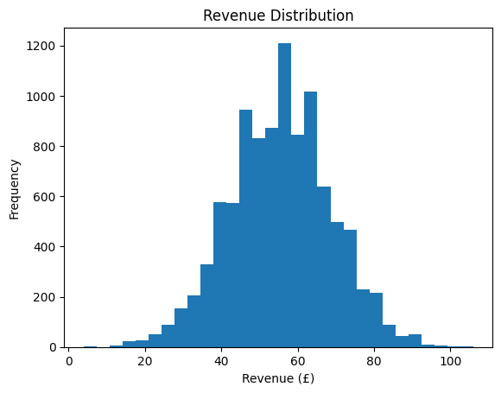

Figure 1: Revenue Distribution Histogram
Figure 1 shows a right-skewed distribution, meaning that a small number of customers generate a much higher level of revenue than the majority. This highlights the importance of identifying and targeting high-value customers.

5.2 Revenue by Advertisement Channel
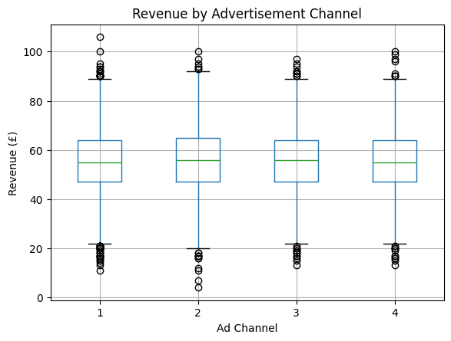
Figure 2: Revenue by Advertisement Channel Boxplot
Figure 2 compares spending across acquisition sources and shows clear differences in customer spending between them. This suggests that the source through which customers are acquired influences how much they spend on the website

5.3 Voucher Usage and Revenue
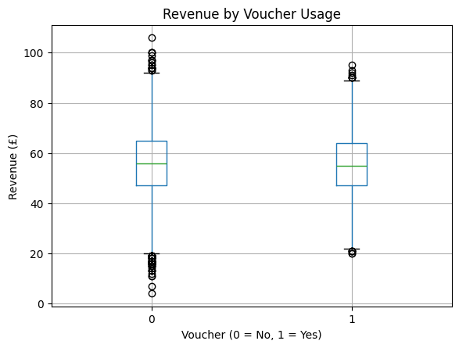
Figure 3: Revenue by Voucher Usage Boxplot
Figure 3 shows that voucher users generally spend slightly less per order than non-voucher users. This suggests that while vouchers may encourage purchase completion, they may also reduce average order value, indicating the need for targeted rather than blanket discounting.

5.4 Website Engagement and Spending
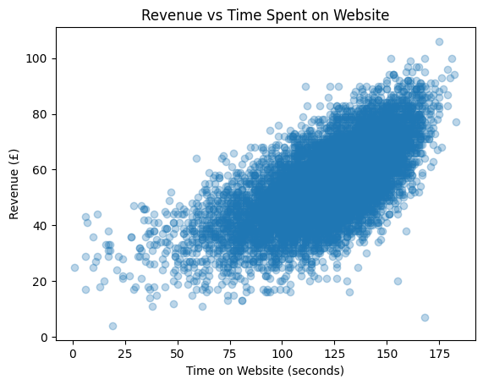
Figure 4: Revenue vs Time on Website Scatter Plot
Figure 4 illustrates a positive relationship between session duration and revenue. Customers who spend more time on the website tend to place higher-value orders. This highlights the revenue impact of improving website usability, navigation, and product discovery.

5.5 Customer History and Revenue
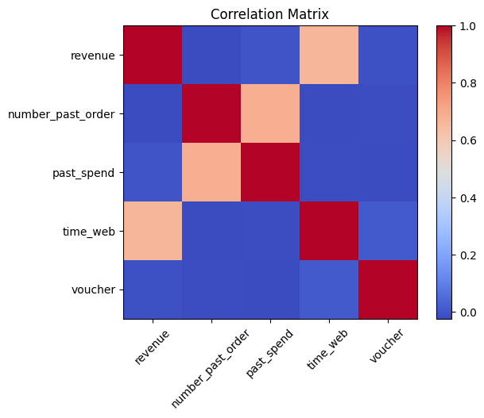
Figure 5: Correlation Matrix
Figure 5 visually demonstrates strong positive correlations between:
- Past spend and current order revenue
- Number of past orders and current order revenue
These figures confirm that existing and loyal customers are the most valuable segment for SweetAroma.

6. Predictive Modelling:

6.1 Objective and Evaluation
The main objective of predictive modelling was to predict customer revenue using behavioural and background variables. The model performance was evaluated using Root Mean Square Error (RMSE), which measures the prediction accuracy in monetary terms.

6.2 Model Comparison
Several models were trained and compared:
- Linear and regularised regression models
- K-Nearest Neighbours
- Random Forest
- Gradient Boosting
Table 3 presents RMSE values for each model
Model | RMSE (£)
Gradient Boosting | 10.143075
Elastic Net | 10.235062
Ridge Regression | 10.235239
Lasso Regression | 10.235273
Linear Regression | 10.235293
KNN | 10.408498
Random Forest | 10.504389

We can clearly see that Gradient Boosting achieved the lowest RMSE value, thus demonstrating a superior predictive accuracy.

6.3 Best Model Selection and Validation
The Gradient Boosting model was selected due to its ability to capture non-linear relationships and interactions between the customer variables.
Here we have model diagnostics to further support the suitability of Gradient Boosting:
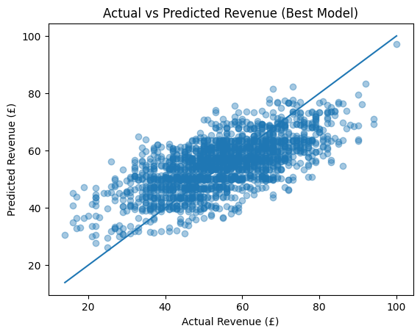
Figure 7 Actual vs Predicted Revenue Plot
Figure 7 demonstrates the close correspondence between forecasted and observed revenue figures.

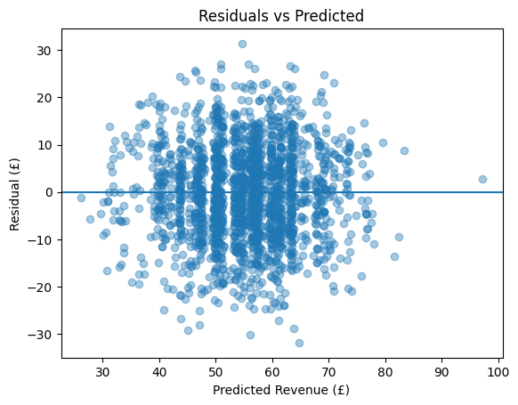
Figure 8: Residual Plot
Figure 8 shows that the residuals are randomly distributed around zero, indicating no systematic bias
Figure 7 and Figure 8 confirm that the model generalises well and is a reliable tool for business use.

7. Business Insights and Recommendations
Based on the analytical findings and supporting evidence presented in the figures, the following recommendations are proposed to improve revenue:
- Prioritise High-Value Existing Customers:
Customers with a high past spend and higher purchase frequency generate a significantly higher revenue.
- Maintain Investment in Paid Advertising:
Paid acquisition channels consistently attract higher-spending customers.
- Apply Targeted Voucher Strategies:
A broad voucher use may reduce the overall order value; thus, focused targeting is recommended.
- Improve Website Engagement:
An increase in session duration has directly resulted in better revenue. Thus, it’s recommended to improve the users’ website experience.
- Use Predictive Targeting for Marketing:
The predictive model enables the proactive identification of high-value customers.

8. Conclusion
This study illustrates SweetAroma's transition from analytics-driven strategy through examination of 10,000 e-commerce transactions from July 2025. The research identifies the key drivers of customer spending and establishes a forecasting framework to support revenue growth.
The findings reveal that historical purchasing behaviour and customer lifetime value are the strongest predictors of revenue performance. This highlights an opportunity for SweetAroma to shift marketing priorities away from volume-based acquisition toward long-term value creation. Repeat high-value customers therefore warrant focused attention through targeted communications, retention initiatives, and premium product offerings.
Website interaction patterns also emerged as important revenue drivers. Extended browsing is associated with higher spending, suggesting that improvements to site navigation, content quality, and personalised product discovery can positively influence transaction value. From a strategic perspective, this positions the digital platform as a revenue-generating asset rather than solely a branding channel.
Analysis of acquisition channels shows that paid promotional channels consistently attract higher-spending customers than organic sources. Although these channels involve higher upfront costs, they deliver stronger revenue per transaction, supporting continued or increased investment. In contrast, voucher usage is associated with slightly lower basket sizes, indicating that promotional activity should be carefully targeted to protect margins.
Finally, the Gradient Boosting prediction model provides SweetAroma with a practical tool for identifying high-value customers prior to purchase completion. This enables timelier marketing interventions, better allocation of resources, and improved marketing efficiency.
Recommended Management Metrics
To operationalise these findings, the following indicators are proposed:
- Forecasted Customer Value Score: for targeting prioritisation
- Mean Transaction Value by Channel: for spend optimisation
- Lifetime Value Growth Trajectory: for sustained value assessment
- Session Duration Metrics: as leading revenue indicators
- Promotion Return Analysis: for discount effectiveness evaluation
- Model Accuracy Tracking: for ongoing performance validation
In summary, this investigation provides SweetAroma with practical intelligence and analytical capabilities that underpin sustained expansion. Integrating these insights into strategic frameworks and performance monitoring will enhance competitive positioning and drive long-term profitability.

9. Predicted Revenue for New Customers:
Using the final Gradient Boosting regression model, revenue predictions were generated for the 20 new customers provided in new_customer25.csv.
These predictions estimate the expected order revenue based on each customer’s background and behavioural characteristics. The results are intended to support SweetAroma’s future marketing evaluation by identifying customers with higher expected spending potential. The predicted values for each order are presented in the table below.
order | prediction
1 | 63.35
2 | 63.29
3 | 46.76
4 | 53.72
5 | 45.40
6 | 57.54
7 | 63.57
8 | 56.84
9 | 61.21
10 | 66.22
11 | 60.47
12 | 46.68
13 | 50.24
14 | 28.93
15 | 60.07
16 | 72.82
17 | 43.94
18 | 50.45
19 | 61.14
20 | 65.48

